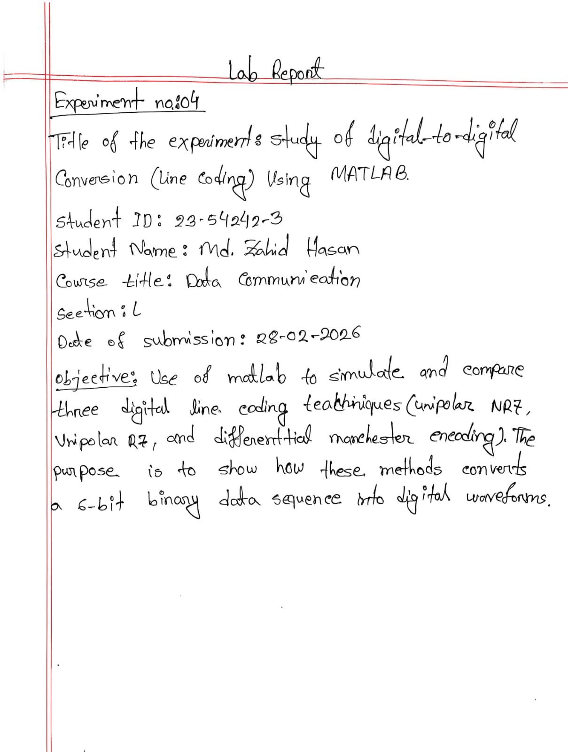

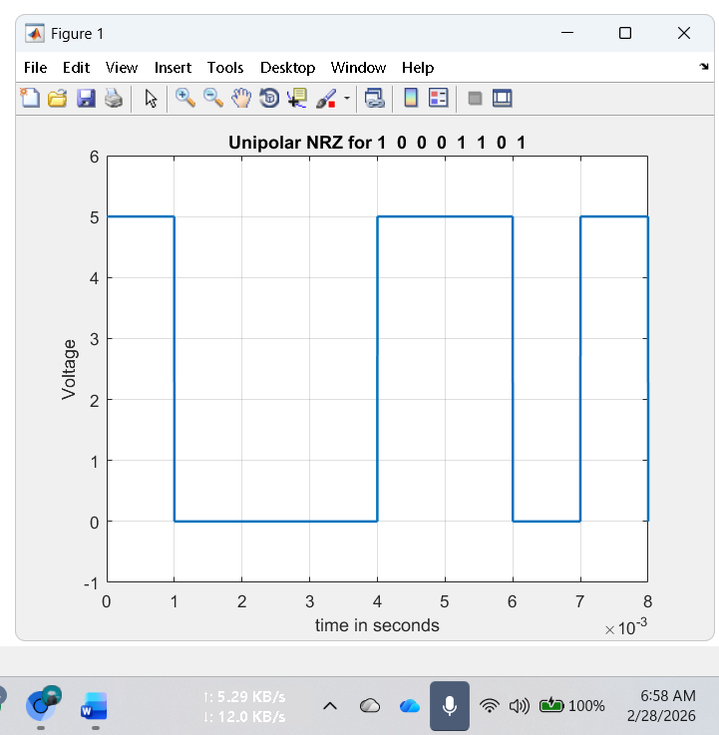
Name: MD. Zahid Hasan
Id: 23-54242-3
Task:1
MATLAB Code: Unipolar NRZ
clc
clear all
close all
bit_stream = [1 0 0 0 1 1 0 1];
no_bits = length(bit_stream);
bit_rate = 1000; % 1 kbps
pulse_per_bit = 1; % for unipolar nrz
pulse_duration = 1/((pulse_per_bit)*(bit_rate));
no_pulses = no_bits*pulse_per_bit;
samples_per_pulse = 500;
fs = (samples_per_pulse)/(pulse_duration); %sampling frequency
% including pulse duration in sampling frequency
% ensures having enough samples in each pulse
t = 0:1/fs:(no_pulses)*(pulse_duration); % sampling interval
% total duration = (no_pulse)*(pulse_duration)
no_samples = length(t); % total number of samples
dig_sig = zeros(1,no_samples);
max_voltage = 5;
min_voltage = 0;
for i = 1:no_bits
if bit_stream(i) == 1
dig_sig(((i-1)*(samples_per_pulse)+1):i*(samples_per_pulse)) = max_voltage*ones(1,samples_per_pulse);
else
dig_sig(((i-1)*(samples_per_pulse)+1):i*(samples_per_pulse)) = min_voltage*ones(1,samples_per_pulse);
end
end
plot(t,dig_sig,'linewidth',1.5)
grid on
xlabel('time in seconds')
ylabel('Voltage')
ylim([(min_voltage - (max_voltage)*0.2) (max_voltage+max_voltage*0.2)])
title(['Unipolar NRZ for ',num2str(bit_stream),''])

Task 2. MATLAB Code Unipolar RZ:
clc
clear all
close all
bit_stream = [1 0 1 0 1 1 0 1];
no_bits = length(bit_stream);
bit_rate = 1000; % 1 kbps
pulse_per_bit = 2; % for unipolar rz
pulse_duration = 1/((pulse_per_bit)*(bit_rate));
no_pulses = no_bits*pulse_per_bit;
samples_per_pulse = 500;
fs = (samples_per_pulse)/(pulse_duration); %sampling frequency
% including pulse duration in sampling frequency
% ensures having enough samples in each pulse
t = 0:1/fs:(no_pulses)*(pulse_duration); % sampling interval
% total duration = (no_pulse)*(pulse_duration)
no_samples = length(t); % total number of samples
dig_sig = zeros(1,no_samples);
max_voltage = 4;
min_voltage = 0;
for i = 1:no_bits
j = (i-1)*2;
if bit_stream(i) == 1
dig_sig((j*(samples_per_pulse)+1):(j+1)*(samples_per_pulse)) = max_voltage*ones(1,samples_per_pulse);
dig_sig(((j+1)*(samples_per_pulse)+1):(j+2)*(samples_per_pulse)) = zeros(1,samples_per_pulse);
else
dig_sig((j*(samples_per_pulse)+1):(j+1)*(samples_per_pulse)) = min_voltage*ones(1,samples_per_pulse);
dig_sig(((j+1)*(samples_per_pulse)+1):(j+2)*(samples_per_pulse)) = zeros(1,samples_per_pulse);
end
end
plot(t,dig_sig,'linewidth',1.5)
grid on
xlabel('time in seconds')
ylabel('Voltage')
ylim([(min_voltage - (max_voltage)*0.2) (max_voltage+max_voltage*0.2)])
title(['Unipolar RZ for ',num2str(bit_stream),''])
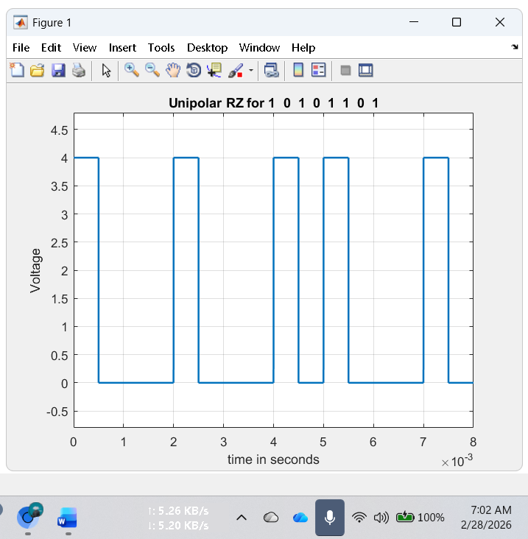

Name: MD. Zahid Hasan
Id: 23-54242-3
Task 3. MATLAB code for Differential Manchester:
Clc
clear all
close all
bit_stream = [1 1 0 0 1 1];
no_bits = length(bit_stream);
bit_rate = 1000; % 1 kbps
pulse_per_bit = 2; % for differential manchester
pulse_duration = 1/((pulse_per_bit)*(bit_rate));
no_pulses = no_bits*pulse_per_bit;
samples_per_pulse = 500;
fs = (samples_per_pulse)/(pulse_duration); %sampling frequency
% including pulse duration in sampling frequency
% ensures having enough samples in each pulse
t = 0:1/fs:(no_pulses)*(pulse_duration); % sampling interval
% total duration = (no_pulse)*(pulse_duration)
no_samples = length(t); % total number of samples
dig_sig = zeros(1,no_samples);
max_voltage = +2;
min_voltage = -2;
inv_bit = 1; % inverting bit
last_state = max_voltage;
inv_last_state = min_voltage; % inverse of last state
for i = 1:no_bits
j = (i-1)*2;
if bit_stream(i) == inv_bit
dig_sig((j*(samples_per_pulse)+1):(j+1)*(samples_per_pulse)) = inv_last_state*ones(1,samples_per_pulse);
dig_sig(((j+1)*(samples_per_pulse)+1):(j+2)*(samples_per_pulse)) = last_state*ones(1,samples_per_pulse);
else
dig_sig((j*(samples_per_pulse)+1):(j+1)*(samples_per_pulse)) = last_state*ones(1,samples_per_pulse);
dig_sig(((j+1)*(samples_per_pulse)+1):(j+2)*(samples_per_pulse)) = inv_last_state*ones(1,samples_per_pulse);
temp_cons = last_state; % temporary constant
last_state = inv_last_state;
inv_last_state = temp_cons;
end
end
figure
plot(t,dig_sig,'linewidth',1.5)
grid on
xlabel('time in seconds')
ylabel('Voltage')
ylim([(min_voltage - (max_voltage)*0.2) (max_voltage+max_voltage*0.2)])
title(['Differential Manchester for ',num2str(bit_stream),', last state = ',num2str(last_state),', inverting bit is ',num2str(inv_bit),''])

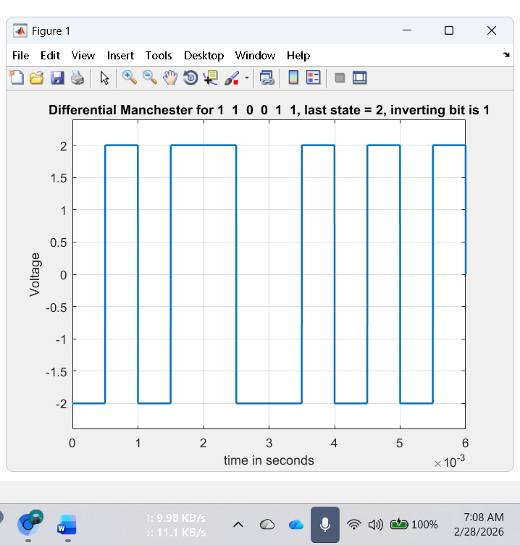

Name: MD. Zahid Hasan
Id: 23-54242-3
Performance Task:
- Polar NRZ-L (4 kbps)
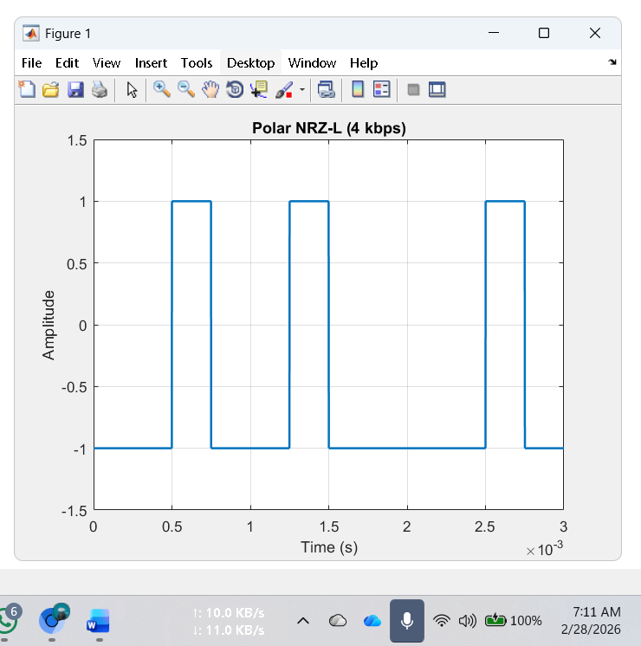
clc;
clear;
close all;

bit_stream = [0 0 1 0 0 1 0 0 0 0 1 0];
Rb = 4000; % 4 kbps
Tb = 1/Rb;
samples = 200;

t = 0:Tb/samples:Tb*length(bit_stream);
signal = [];

for i = 1:length(bit_stream)
if bit_stream(i)==1
signal = [signal ones(1,samples)];
else
signal = [signal -ones(1,samples)];
end
end

t = linspace(0,Tb*length(bit_stream),length(signal));

plot(t,signal,'LineWidth',1.5)
ylim([-1.5 1.5])
grid on
title('Polar NRZ-L (4 kbps)')
xlabel('Time (s)')
ylabel('Amplitude')

- Manchester (2 kbps)

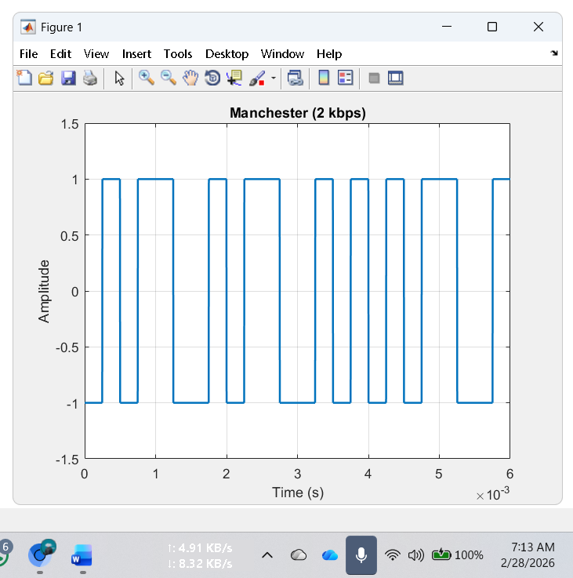
clc;
clear;
close all;

bit_stream = [0 0 1 0 0 1 0 0 0 0 1 0];
Rb = 2000; % 2 kbps
Tb = 1/Rb;
samples = 200;

signal = [];

for i = 1:length(bit_stream)
if bit_stream(i)==1
signal = [signal ones(1,samples/2) -ones(1,samples/2)];
else
signal = [signal -ones(1,samples/2) ones(1,samples/2)];
end
end

t = linspace(0,Tb*length(bit_stream),length(signal));

plot(t,signal,'LineWidth',1.5)
ylim([-1.5 1.5])
grid on
title('Manchester (2 kbps)')
xlabel('Time (s)')
ylabel('Amplitude')

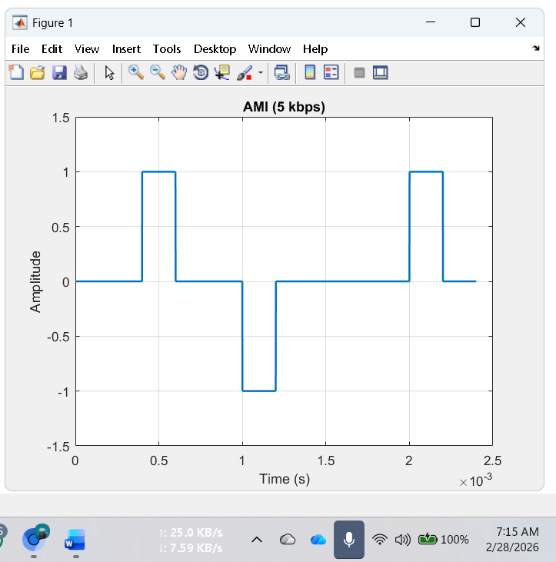
Name: MD. Zahid Hasan
Id: 23-54242-3
- AMI (5 kbps)
clc;
clear;
close all;

bit_stream = [0 0 1 0 0 1 0 0 0 0 1 0];
Rb = 5000;
Tb = 1/Rb;
samples = 200;

signal = [];
polarity = 1;

for i = 1:length(bit_stream)
if bit_stream(i)==1
signal = [signal polarity*ones(1,samples)];
polarity = -polarity;
else
signal = [signal zeros(1,samples)];
end
end

t = linspace(0,Tb*length(bit_stream),length(signal));

plot(t,signal,'LineWidth',1.5)
ylim([-1.5 1.5])
grid on
title('AMI (5 kbps)')
xlabel('Time (s)')
ylabel('Amplitude')

- MLT-3 (10 kbps)
clc;
clear;
close all;

bit_stream = [0 0 1 0 0 1 0 0 0 0 1 0];
Rb = 10000;
Tb = 1/Rb;
samples = 200;

signal = [];
levels = [0 1 0 -1];
index = 1;

for i = 1:length(bit_stream)
if bit_stream(i)==1
index = index + 1;
if index > 4
index = 1;
end
end
signal = [signal levels(index)*ones(1,samples)];
end

t = linspace(0,Tb*length(bit_stream),length(signal));

plot(t,signal,'LineWidth',1.5)
ylim([-1.5 1.5])
grid on
title('MLT-3 (10 kbps)')
xlabel('Time (s)')
ylabel('Amplitude')
